H.T No
Regulations:
A15

Sreenidhi Institute of Science and Technology
(An Autonomous Institution)
Code No: 5H213 Date: 28-Aug-2023 (FN)

B.Tech I-Year II- Semester External Examination, Aug/Sept-2023 (Supplementary)
ENGINEERING MATHEMATICS – II (Common to All except BT)

Time: 3 Hours Max.Marks:75 Note: a) No additional answer sheets will be provided.
b) All sub-parts of a question must be answered at one place only, otherwise it will not be valued.
c) Missing data can be assumed suitably.

Bloom's Cognitive Levels of Learning (BCLL)
Remember | L1 | Apply | L3 | Evaluate | L5
Understand | L2 | Analyze | L4 | Create | L6

Part - A Max.Marks:25

Answer all QUESTIONS.
 |  | BCLL | CO(s) | Marks
1 | Find the value of such that the vectors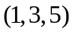, 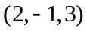 and 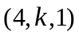are linearly dependent. | L2 | CO1 | [2M]
2 | Find the Eigen values of 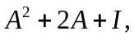where 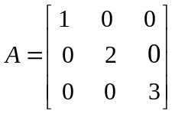 | L2 | CO2 | [2M]
3 | Form the partial differential equations by eliminating the arbitrary function from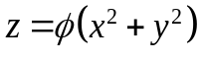 | L3 | CO3 | [2M]
4 | Find the Laplace transform of 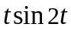 | L2 | CO4 | [2M]
5 | Find the 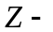transform of 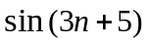 | L2 | CO5 | [2M]
6 | Find the Fourier sine transform of 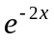 | L2 | CO6 | [3M]
7 | Find the rank of the matrix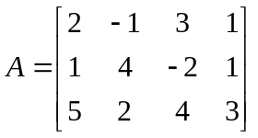 | L3 | CO1 | [3M]
8 | Find the complete integral of 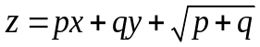 | L3 | CO3 | [3M]
9 | Evaluate 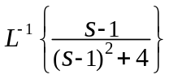 | L2 | CO4 | [3M]
10 | Find the Fourier coefficient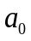for the function 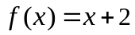in 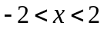 | L2 | CO6 | [3M]

Part – B Max.Marks:50
ANSWER ANY FIVE QUESTIONS. EACH QUESTION CARRIES 10 MARKS.

 |  |  | BCLL | CO(s) | Marks
11. | a) | Find the rank of the matrix 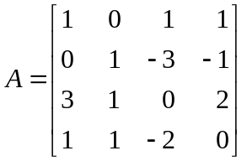by reducing into normal form | L3 | CO1 | [5M]
 | b) | Solve | L4 | CO1 | [5M]
12. | a) | Find the Eigen values and corresponding Eigen vectors of the matrix 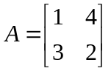 | L3 | CO2 | [5M]
 | b) | Verify Cayley-Hamilton theorem for the matrix 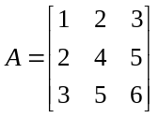 | L4 | CO2 | [5M]
13. | a) | Solve 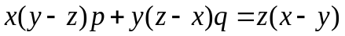 | L4 | CO3 | [5M]
 | b) | Use method of separation of variables to solve 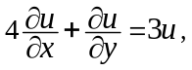given 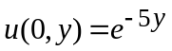 | L4 | CO3 | [5M]
14. |  | Use Laplace transforms to solve | L3 | CO4 | [10M]
15. | a) | Evaluate 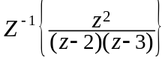by convolution theorem | L3 | CO5 | [5M]
 | b) | Find the inverse 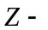transform of 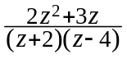 | L4 | CO5 | [5M]
16. | a) | Obtain the half-range Fourier cosine series for the function  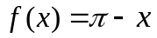 in 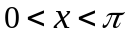 | L3 | CO6 | [5M]
 | b) | Find the Fourier transform of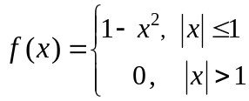 | L4 | CO6 | [5M]
17. | a) | Find the inverse of the matrix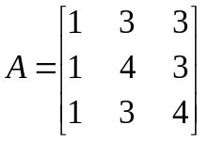 using Gauss - Jordan method | L3 | CO1 | 5M]
 | b) | Solve 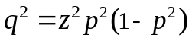 | L4 | CO2 | [5M]
18. | a) | Evaluate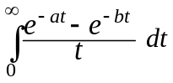 | L3 | CO4 | [5M]
 | b) | If 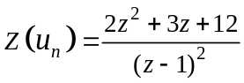 , evaluate 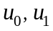 | L3 | CO5 | [5M]

-- 00 -- 00 –

